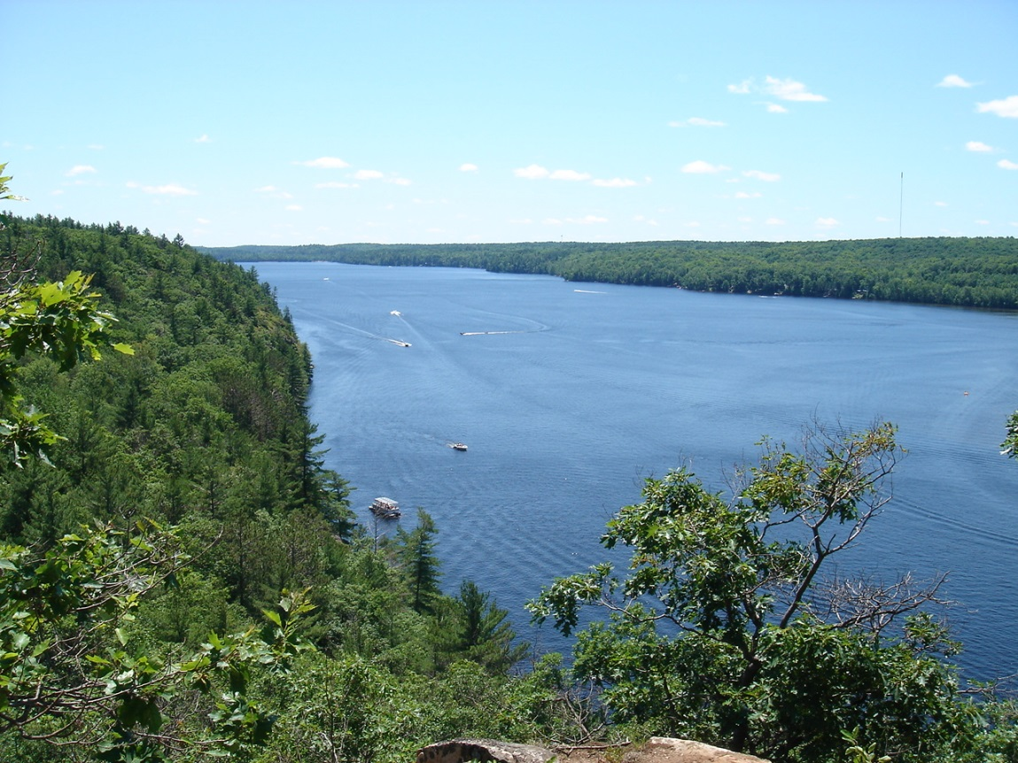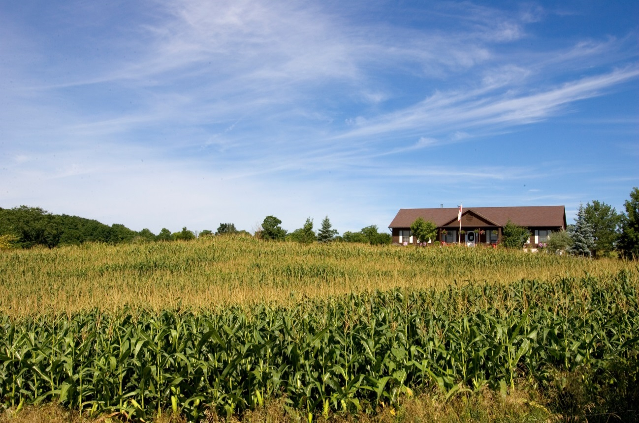

**Environment and**

**Land Tribunals Ontario**

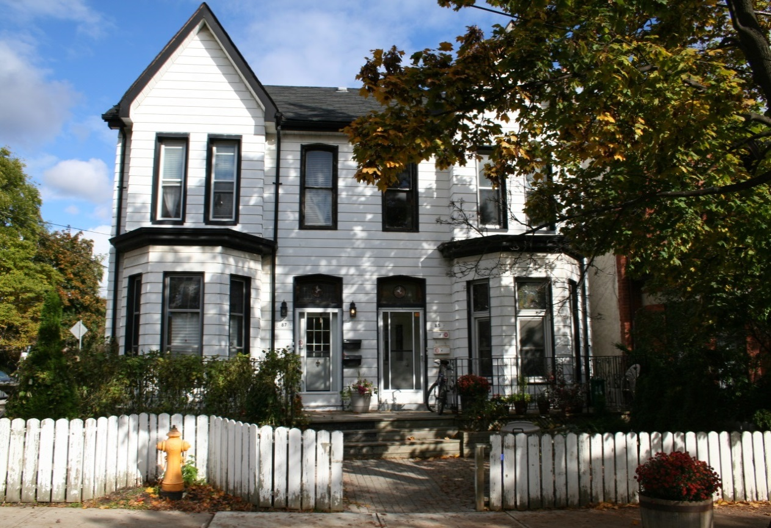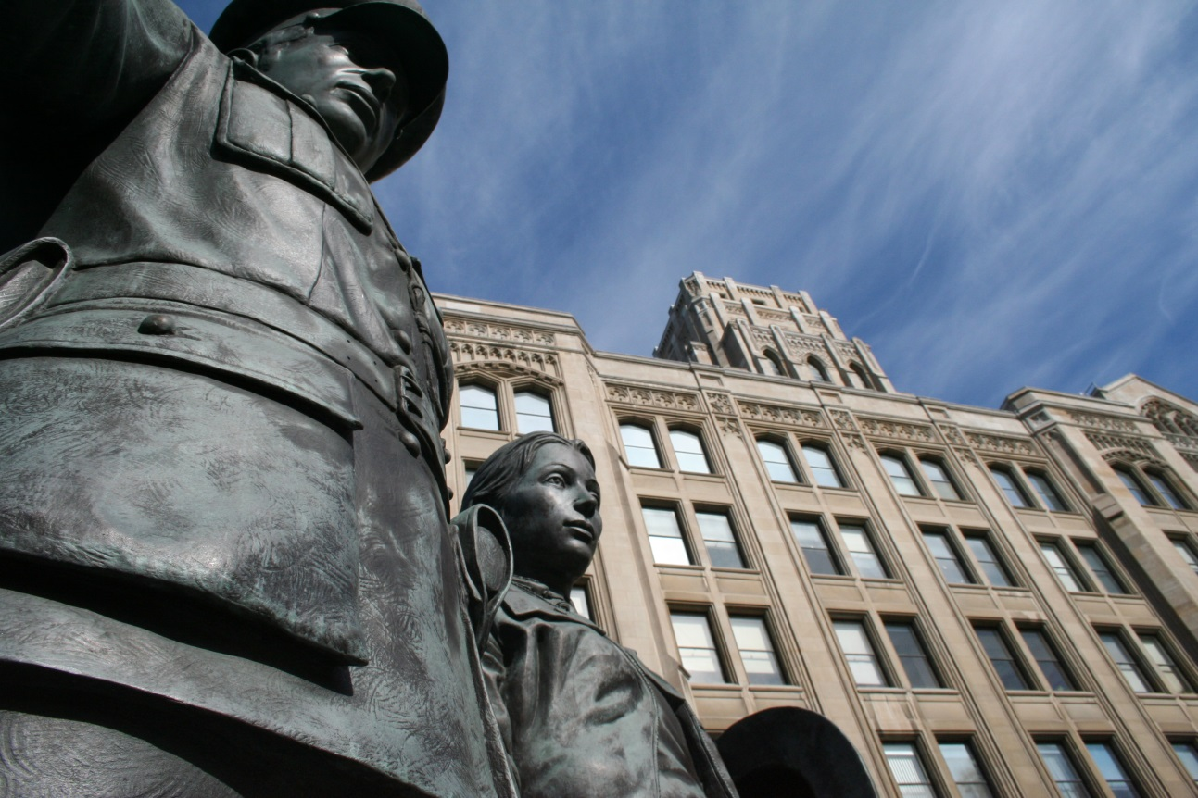

2016-17 Annual Report

2016-17 Annual Report



**Environment and Land Tribunals Ontario (ELTO)**

655 Bay Street, Suite 1500, Toronto, Ontario M5G 1E5

Phone: (416) 212-6349 or toll-free at 1-866-448-2248

Fax: (416) 314-3717 or toll-free at 1-877-849-2066 Website: [elto.gov.on.ca](http://elto.gov.on.ca)

Disponible en français

For an accessible version of this document in English and French, please visit: **elto.gov.on.ca**

ISSN 1925-6876

ISBN 978-1-4868-0369-9

© Queen’s Printer for Ontario, 2017

|  |  |  |  |
| --- | --- | --- | --- |
| **Environment and Land Tribunals Ontario** | | **Tribunaux de l’environnement et de l'aménagement du territoire Ontario** | |
| 655 Bay Street, Suite 1500  Toronto ON M5G 1E5 | | 655 rue Bay, suite 1500  Toronto ON M5G 1E5 | |
| Telephone:  Toll Free:  Fax:  Toll Free:  Website: | (416) 212-6349  1-866-448-2248  (416) 645-1819  1-866-297-1822  elto.gov.on.ca | Téléphone:  Sans Frais:  Télécopieur:  Sans Frais  Site Web: | (416) 212-6349  1-866-448-2248  (416) 645-1819  1-866-297-1822  elto.gov.on.ca |

June 30, 2017

The Honourable Yasir Naqvi

Attorney General of Ontario

Ministry of the Attorney General

11th Floor, 720 Bay Street

Toronto, Ontario

M7A 2S9

Dear Attorney General Naqvi:

Re**:** Environment and Land Tribunals Ontario 2016-17 Annual Report

On behalf of Environment and Land Tribunals Ontario, it is our pleasure to submit to you our 2016-17 Annual Report. This report reflects the cluster’s activities for the fiscal year ending March 31, 2017.

Environment and Land Tribunals Ontario is committed to delivering the initiatives outlined in this report, implementing our strategic framework as outlined in our 2017-18 to

2019-20 business plan, and providing high quality services to the people we serve.

We look forward to working with your ministry in the upcoming year.  
  
Yours Sincerely,





Bruce Krushelnicki Ellen Wexler

Executive Chair Executive Lead

Environment and Land Tribunals Ontario Environment and Land Tribunals Ontario



**Table of Contents**

**5** Executive Chair’s Message

**9** Executive Lead’s Message

**11** Mandate and Mission

**12** Vision and Core Values

**14** About ELTO

**16** Public and Governance Accountability

**17** Diversity, Inclusion and Accessibility

**20** Recruitment of Members

**22** Professional Development

**23** Public Engagement and Consultations

**24** Performance Results

**26** Financial Summary

**27 Assessment Review Board**

**31 Board of Negotiation**

**33 Conservation Review Board**

**36 Environmental Review Tribunal**

**40 Ontario Municipal Board**

**44 The Future of ELTO**

**46 Appendix A: ELTO’s Appointees**

### **Executive Chair’s Message**

Once again I am pleased to submit the Annual Report, on this occasion for the 2016-17 fiscal year, on behalf of the members and staff of Environment and Lands Tribunal Ontario (ELTO).

**The Membership**

As we expected and reported in the previous year, the preoccupation of our tribunals has been to manage caseloads while recruiting new members and promoting existing members to positions that have become vacant due to the combination of the 10-year limit on appointments and normal anticipated departures.

Seventeen ELTO positions were filled in the fiscal year, including five full-time members and two new part-time members to the Ontario Municipal Board (OMB). Four part-time members were promoted into full-time positions, three at the Assessment Review Board (ARB) and one at the Environmental Review Tribunal (ERT), and several members changed positions. One important change in position was the appointment of OMB Vice-Chair James McKenzie to the post of OMB Associate Chair, replacing Wilson Lee who retired as OMB Associate Chair and was appointed as a part-time mediator.

Twenty people (both full and part-time) left ELTO in the past year, representing a loss of about thirty percent of the Order-in-Council members – a very significant loss of experience and expertise. The departures included many very long standing members of the tribunals, who will be missed for their experience and leadership at ELTO. This includes distinguished retiring members such as ARB Vice-Chair Peter Andrews and OMB Vice-Chair Steven Stefanko.

Our plan over the last year and a half has been to weather the period of departures by adopting a vigorous plan for recruitment and promotion, combined with an intense program of professional development and training. We anticipated the changes that were to come and set about to ensure that our complement of members would eventually be sustained and that the roster of qualified members would be available to undertake all facets of adjudication and mediation at ELTO.

Despite our best efforts, several member positions remain vacant and others are in the process of being filled by ongoing recruitment. The completion of the plan in the 2017-18 fiscal year will mean that ELTO should be at full complement by the end of 2017. Following that, a more normal rate of turnover should be expected.

**Senior Staffing Changes**

Turnover has not only affected the Order-in-Council appointees to the tribunals. This past fiscal year also saw changes to the ranks of the senior staff at ELTO. Both the OMB and the ARB have new Registrars following the retirement of Joanne Hayes, former registrar for the Conservation Review Board (CRB), ERT and OMB, and Shirley Lee Collins, former registrar for ARB and the Board of Negotiation (BON). Both were succeeded by former deputy-registrars Mary Ann Hunwicks and Kelly Triantafilou, a reflection of the “bench strength” of ELTO staff and a sound succession plan.

At the head of staff, Ellen Wexler has been made Executive Lead of ELTO following the departure of Anne Marie Predko. Ellen will also be acting as Executive Lead to the other two clusters of the Ministry of the Attorney General: Social Justice Tribunals Ontario (SJTO) and Safety, Licensing Appeals and Standards Tribunals Ontario (SLASTO). Mira Gamsa has been appointed Director of Operations.

**Assessment Review Board (ARB)**

Recruitment has not been our only preoccupation. The ARB has recently completed an extensive project of rule changes following wide consultation with stakeholders. The aim is to bring the rules up to date and to prepare for the new cycle of re-assessments that recently took place and which will result in a fresh round of appeals in 2017.

The new rules, combined with increased efforts by ARB management and stakeholders to bring additional discipline to the management of the case files, should result in fewer case management events such as telephone conference calls, adjournments and continuances, and more case resolutions over the course of the four-year cycle. The aim is to enforce a firm schedule of hearings, eliminate backlog and leave a minimal carryover of cases to the next cycle. The ARB has continued to experience its high volume caseload of 55,769 appeals (as of March 31, 2017).

**Board of Negotiation (BON)**

The BON continues to experience a robust caseload of 70-80 cases per year. The BON provides a mediation service at the front end of the expropriation process to permit and encourage parties to settle issues of financial compensation arising from the taking of lands or other damages and losses of value associated with an expropriation or a public project.

The workload of the BON is affected by the many infrastructure projects underway in the province. These include major transit projects, highways and the construction and renewal of other public works, many of which require the taking of privately owned lands. As a result of the BON’s mediation efforts and the negotiation by parties of many of the matters that are received, more than 80 percent of disputes are resolved without the need for expensive and time-consuming arbitration by the OMB and the courts.

**Conservation Review Board (CRB)**

In the case of the CRB, we note that provincial plans and policies that encourage redevelopment, infill and intensification within the built-up areas of cities are leading to an increase in heritage issues associated with redevelopment. This can be expected to increase as more infill and intensification projects are proposed within traditional, existing urban areas in Ontario.

Along the same line, there seems to be an increase in cases where the issues associated with a heritage designation and site specific land redevelopment proposal require consideration under both the *Ontario Heritage Act* (under the CRB) and the *Planning Act* (under the OMB). While it is not possible to consolidate matters arising under the two acts, in some selected cases with the consent of the parties, ELTO has been able to schedule consecutive hearings by members who are cross appointed to the OMB and the CRB so as to provide a consistent single disposition of all matters under both acts.

**Environmental Review Tribunal (ERT)**

Among over 1,200 environmental courts and tribunals worldwide, the ERT was recently profiled as a “very impressive independent environmental tribunal” that “exemplifies a large number of best practices, including highly trained adjudicators” by the United Nations in its publication: “Environmental Courts & Tribunals: A Guide for Policy Makers” (2016).

The ERT continues to manage its base caseload of 70-80 hearings per year. A temporary hiatus in new renewable energy approval appeals caused by a gap in the government procurement process is expected to end in the next fiscal year, leading to a return to historical caseload levels. During the past fiscal year, some members of the ERT who are cross appointed to the OMB have been assisting with the OMB caseload while that tribunal adjusts to a number of member departures due to the 10-year limitation on appointments.

Cross-appointments and cross-training of ELTO members are creative ways of addressing periodic imbalances in caseloads among the tribunals. As a cluster, ELTO makes prudent use of cross appointments to provide variety in member assignments and address the ups and downs of caseloads.

**Ontario Municipal Board (OMB)**

The OMB awaits the results of the OMB Reform process initiated by the Ministry of Municipal Affairs (MMA) and the Ministry of the Attorney General (MAG) pursuant to their mandate letters. The review began in fall 2016 with a public engagement process based on a consultation document that outlined the challenges and options for reform of the “scope and effectiveness” of the OMB. The public consultation ended in early 2017 and staff of the ministries consulted with the OMB leadership and staff on possible reforms. The results of the process – expected to be a package of legislative and policy reforms -- are likely to be announced in the 2017-18 fiscal year with consideration by the legislature in fall 2017.

The OMB has also assisted with the anticipated implementation of the Toronto Local Appeals Body (TLAB) for variance and consent appeals of City of Toronto Committee of Adjustment appeals. It is expected that 300-400 of the shorter Toronto appeals that were formerly heard by the OMB each year will be heard by the TLAB commencing in May 2017.

**Mediation**

Mediation is encouraged across all the ELTO tribunals. Many of our members are trained mediators and receive ongoing professional development in mediation and negotiations skills. Mediation is often a preferred method for resolving disputes as it is entirely voluntary, relying on goodwill and a spirit of compromise and accommodation among parties. Most importantly, it is a resolution that is not imposed on the parties by a decision of the tribunal, but is adopted by the parties themselves to avoid what can often be an expensive, time-consuming and disagreeable experience.

To conclude, the tribunals of ELTO continue to manage strong caseloads going into the next year. Our efforts to recruit new members to withstand the pressures of member and staff turnover are nearly complete and all the tribunals are responding to the need for member training and professional development to align with new member recruitment. In addition, all the tribunals are continuously seeking ways to improve their adjudicative and mediation services through continuous improvement, rule changes and government-led reform of our jurisdiction processes to deliver a higher level of services to the public.

It is my honour and my pleasure to submit this report on behalf of all of us here at ELTO.

Sincerely,



Bruce Krushelnicki

Executive Chair

### **Executive Lead’s Message**

It has been another exciting year at Environment and Land Tribunals Ontario (ELTO). Much work was done this year to implement changes and support the vision of providing timely dispute resolution services. I am very impressed with the efforts of staff and members for this year.

ELTO has made a commitment to improve information access to its clients and to use technology to accomplish this. We want to provide information to the public in a variety of formats and help them better understand our services and processes. In fall 2016, ELTO began developing a series of YouTube videos, with the first in the series launched in spring 2017 on the Citizen Liaison Office (CLO), showcasing how ELTO can support the public to better understand the tribunals, their processes, how an appeal can be filed and more. This year, ELTO also began work on redesigning its website – another initiative we expect to come to fruition in early 2017-18.

In fall 2016, the government asked the Ministry of Municipal Affairs (MMA) and the Ministry of the Attorney General (MAG) to conduct a mandate review of the Ontario Municipal Board (OMB) to ensure its continued effectiveness. As a result, we anticipate the government will be announcing proposed changes to the jurisdiction and operations processes of OMB.

On March 29, 2017, the City of Toronto passed a bill to establish the Toronto Local Appeal Body (TLAB), with an effective date of May 3, 2017. This means that the majority of minor variance and consent appeals from the Toronto Committee of Adjustment would go to the TLAB instead of the OMB. Accordingly, many of ELTO’s best practices were shared with the TLAB. The creation of the TLAB will result in a decreased caseload for the OMB, and will provide an opportunity for the OMB to allocate resources to respond to the service recommendations that result from the OMB mandate review.

This fiscal year, the Conservation Review Board (CRB) has continued to see a substantial increase in file intake and hearing activity. In spite of this increase in activity, the CRB has exceeded its performance target of 85 per cent of hearing reports issued within 30 days of the hearing end date. It also continues its commitment to encouraging negotiated settlements prior to a hearing, and to a cost-efficient and timely adjudication process.

The Assessment Review Board (ARB) developed new Rules of Practice and Procedure that took effect on April 1, 2017. These rules were developed following extensive stakeholder consultations conducted throughout 2016. An Appeals Management Advisory Committee was established, comprised of representatives from ARB’s stakeholders, the Municipal Property Assessment Corporation (MPAC) and municipalities. The purpose of this committee is to monitor the application of the rules and recommend any amendments to the Rules by the middle of the current assessment cycle, in 2019.

We were pleased to see the efforts of the Environmental Review Tribunal (ERT), including the provision of numerous plain-language guides to ERT proceedings, recognized as ”best practices” in a new United Nations report on environmental courts and tribunals.

ELTO will continue to undertake ambitious changes and tackle challenges to ensure our organization serves the changing interests of the public. I would like to thank all staff and members at ELTO for their hard work and I look forward to another exciting year to come, filled with good work and proud achievements.

Sincerely,



Ellen Wexler  
Executive Lead

**Mandate and Mission**

Shortly after its creation, the Environment and Land Tribunals Ontario (ELTO) established mandate and mission statements. In 2015, ELTO implemented an updated strategic framework, including updating the mandate and mission statements.

**Mandate Statement**

Environment and Land Tribunals Ontario is a cluster of five tribunals that effectively and efficiently resolve disputes related to land use planning, environmental and heritage protection, property assessment, land valuation and other matters.

**Mission Statement**

We deliver modern, fair, responsive, accessible, effective and efficient dispute resolution services that support strong, healthy communities and the public interest.

**Vision and Core Values**

#### Vision

We are focused on serving the interests of all Ontarians and committed to excellence in the timely, evidence-based resolution of environment and land disputes.

#### Core Values

The core values at the Environment and Land Tribunals Ontario (ELTO) are the guiding principles of the cluster. These core values form the foundation upon which ELTO’s constituent tribunals fulfill their mandates:

**Accessibility**

* Publications, communications and facilities, including hearing and mediation rooms, will provide for full and equitable access.
* Diversity will be fully respected and reflected in all that ELTO does.
* Processes will be designed in a way that facilitates informed participation.
* Proceedings will be conducted in a manner which is welcoming and respectful.
* Practices and procedures will provide for a meaningful, effective opportunity to be heard on the relevant issues to be resolved in a particular case.

**Consistency and Responsiveness**

* Procedures and outcomes will demonstrate consistency while remaining responsive to differing cases, party needs and an evolving development of the law.

**Continuous Improvement**

* By being proactive in modernizing ELTO, the changing needs of Ontarians will be met.

##### **Fairness**

* Proceedings will be conducted impartially.
* Decisions will be principled and based on the facts, the applicable law and policy and on the merits of the case.

##### **Integrity, Professionalism and Independence**

* Members and staff will act with honesty, integrity and professionalism, exhibiting the highest standards of public service.
* Members and staff will work together to build public confidence in ELTO, its constituent tribunals and the administration of justice.
* ELTO and its constituent tribunals must be, and be seen to be, neutral, unbiased and independent from improper influence.

**Timeliness and Efficiency**

* Proceedings will be conducted in a just, expeditious and cost-effective manner, and will be proportional to the issues that must be determined to resolve the dispute.
* Decisions will be issued as soon as possible after a proceeding.

**Transparency and Accountability**

* Tribunal procedures, rules, policies and decisions will be clear and readily available to the public.
* Reasons for decisions will be concise and will explain how the decision was reached.
* Through the provision of accurate public information, ELTO will be accountable to Ontarians.

**About ELTO**

**Legislative Authority**

Environment and Land Tribunals Ontario (ELTO) was formed in 2010, and was the first cluster of tribunals created under the authority of the *Adjudicative Tribunals Accountability, Governance and Appointments Act, 2009* (ATAGAA). This act permits the government to designate two or more adjudicative tribunals as a cluster if, in the opinion of the Lieutenant Governor in Council, the matters that the tribunals deal with are such that they can operate more effectively and efficiently as part of a cluster than alone. ELTO brings together five Ontario tribunals that adjudicate and provide dispute resolution services related to land use planning, environmental and heritage protection, property assessment, land valuation and other matters.

ELTO comprises the following five tribunals, under the responsibility of the Ministry of the Attorney General (MAG):

* **Assessment Review Board (ARB)**
* **Board of Negotiation (BON)**
* **Conservation Review Board** **(CRB)**
* **Environmental Review Tribunal** **(ERT)**
* **Ontario Municipal Board** **(OMB)**

**ELTO**

|  |  |  |  |  |
| --- | --- | --- | --- | --- |
| **ARB** | **BON** | **CRB** | **ERT** | **OMB** |

The cluster is led by an Executive Chair, who also assumes the powers, duties and functions legislatively assigned to the chair of each constituent tribunal. While under the leadership of the Executive Chair, each tribunal maintains its legislative mandate and remains independent in its decision-making.

**What We Do**

All five ELTO tribunals promote the resolution of disputes through settlements generated by mediation or alternatives to traditional hearings. Four of the five ELTO tribunals hold formal hearings when disputes are not resolved by alternative approaches.

ELTO proceedings are held throughout the province. ELTO tribunals use a variety of dispute resolution methods and conduct different hearing events, including formal hearings on the merits of the case, pre-hearings, motion hearings and mediation sessions. The tribunals process the files from intake, through to a hearing if required, and issue decisions, orders and recommendations resulting from settlements, hearings and mediations.

C:\Users\HernanC\Downloads\BoldedVersion.png

*

**(43 full-time)**

**(33 part-time)**

**(5)**

**(7)**

**(1)**

**(28)**

**(17)**

**(25)**

**(36)**

\***Note**: Numbers refer to full-time equivalent (FTE) allocations.

**Public and Governance Accountability**

The *Adjudicative Tribunals Accountability, Governance and Appointments Act, 2009* (ATAGAA) and related regulations have further strengthened and made transparent the accountability framework for adjudicative tribunals through provisions regarding requirements for accountability documents, including: mandate and mission statements, consultation policies, service standard policies, ethics plans and member accountability frameworks (such as position descriptions and codes of conducts), memoranda of understanding, business plans and annual reports.



**Business Plans**

**Annual Reports**

**Memoranda of Understanding**

**Diversity, Inclusion and Accessibility**

## The Diversity, Inclusion and Accessibility Plan at Environment and Land Tribunals Ontario (ELTO) is designed to:

* Reflect the public served at all levels of the ELTO workforce.
* Reinforce a workplace free from harassment and discrimination.
* Embed diversity objectives and outcomes in ELTO policies, processes and services.
* Respond to the needs of diverse stakeholder groups.

## The plan includes strategies to address people, processes, services and results. It incorporates a Multi-Year Accessibility Plan, developed in 2013, through consultation with persons with disabilities.

## For the 2016-17 fiscal year, ELTO focused on delivering initiatives to support the following priorities:

* Provide a strong mandate for members and staff to adopt best practices that embed diversity, inclusion and accessibility in the planning and delivery of activities.
* Mentor and develop diversity champions among members and staff.
* Support the ongoing commitment to continuous learning by documenting education, awareness and acceptance of diversity, inclusion and accessibility in performance and learning plans.

## Accessible Built Environment and Hearing Space

## ELTO’s built environment reflects a universal design that includes accessible features for clients, adjudicators and staff. Services and support, such as augmented hearing devices and universal signage, are in place to support accessibility.

## ELTO also provides accessible hearing rooms at its offices in Toronto, and maintains a directory of contacts and accessibility features for the hearing spaces it uses in municipal buildings across the province.

**Accommodation Requests**

Administrative and adjudicative protocols are in place to allow for full and meaningful participation of the public where requests for accommodation are made. ELTO’s members and staff have been trained to recognize and respond to accommodations requests for those who access our services. All correspondence, invitations to stakeholder consultation meetings, hearing notices and website pages include a note offering accommodation upon request.

For the 2016-17 fiscal year, ELTO’s Accessibility Coordinator played a key role in the receipt, acknowledgement and follow-through on nine accommodation requests.

While the overall number of accommodation requests continues to decline, the complexity of requests has increased. This is attributed to an increased public awareness of a wide range of accessibility barriers and the public’s right to request accommodation.

**Accommodation Requests for ELTO**

|  |  |  |  |
| --- | --- | --- | --- |
| **Fiscal Year** | **2014-2015** | **2015-2016** | **2016-2017** |
| Number of Requests | 23 | 14 | 9 |

**Accessibility and Diversity Training**

Mandatory training in the areas of customer service policy under the *Accessibility for Ontarians with Disabilities Act, 2005* (AODA), the Integrated Accessibility Standards Regulation (IASR) and the Ontario Human Rights Code (OHRC) was delivered to all new members and staff.

ELTO also delivered learning events throughout the year to reinforce the values of respect for diversity and inclusion:

* Assessment Review Board (ARB) members received specialized training on the challenges faced by diverse and vulnerable clients who wish to participate in poverty-related tax reduction appeals, and the support that can be provided to them to ensure their inclusion and a fair hearing.
* ELTO staff attended a session on “Indigenous Realities”, presented by the Indigenous Justice Division of the Ministry of the Attorney General (MAG).
* ELTO staff also attended a session on the “Mental Health First Aid initiative” by ELTO’s Mental Health First Aid Responder. This encouraged other staff members to complete additional training to become mental health first aid responders as well.

Results on accessibility training commitments are currently measured and reported annually to MAG.

**Accessible Website and Information**

Accessible information products developed in plain language are available on the ELTO website. ELTO’s information products are available in English and French. Where web content cannot be made accessible, ELTO provides an active offer of documents in an alternative format. In addition, accessibility and diversity resources and tools for members and staff are maintained on the ELTO intranet site.

Throughout 2016-17, ELTO has continued to improve its accessibility knowledge by offering training to webmasters, communication staff and content contributors on creating and maintaining accessible websites.

**Accessible Employment and Hiring Practices**

ELTO managers continue the practice of offering and providing accommodation throughout the recruitment process to address visible and invisible disabilities, and to promote respect and professionalism as hallmarks of the workplace.

Managers actively reach out to staff to offer and put accommodation plans in place where required. All members and staff who require evacuation assistance have emergency evacuation plans in place.

**Recruitment of Members**

The *Adjudicative Tribunals Accountability, Governance and Appointments Act, 2009* (ATAGAA) requires the selection process for the appointment of new members to be competitive and merit‐based. It also requires that all new appointments have the support of the Executive Chair, who makes initial recommendations of new members to Ontario’s Attorney General.

Environment and Land Tribunals Ontario (ELTO) has developed a succession and recruitment plan for OICs using an orderly and fair process to minimize the impact on ELTO’s service to the public. This is part of ELTO’s Human Capital Plan and in response to the Government’s 10-year rule for OICs. The ELTO cross-appointment strategy ensures the most efficient and effective use of ELTO’s OICs. By appointing OICs to more than one tribunal, according to their skills and substantive areas of knowledge, ELTO can assign designated full-time and part-time appointees to hearings where the need is greatest among the tribunals.

ELTO has implemented an aggressive and proactive recruitment plan. The plan addresses the expected losses by implementing a strategy that ensures the impacts on ELTO services can be minimized. Through a number of competitions in 2016-17, ELTO attracted a high number of candidates with the relevant background, training and skills to fill these vacant member positions.

The Assessment Review Board (ARB) has begun to transform into a tribunal with a greater proportion of full-time positions. Competitions were successfully completed for five full-time members and a vice-chair, while competitions for one part-time member and two additional full-time vice-chairs are in progress.

At the Board of Negotiation (BON), recruitment began in November 2016 for two part-time members. At the Conservation Review Board (CRB), advertising began in February 2017 for a part-time vice-chair. Once these positions are filled, the BON and the CRB will be in a position to address existing and future caseloads.

At the Environmental Review Tribunal (ERT), a full-time vice-chair was successfully recruited, while competitions for two additional full-time vice-chairs and two part-time members are in progress.

The Ontario Municipal Board (OMB) has experienced the most significant loss of full-time experienced members. The plan for the OMB aims to maintain the roster in the face of an ongoing caseload. This includes a combination of short appointment extensions and a vigorous program of recruitment and training. Competitions were successfully completed for two part-time members, five full-time members and a full-time associate chair, while competitions for two full-time vice-chairs and two full-time members are in progress.

New member training and ongoing professional development for all the tribunals will be vital to ensure the successful introduction of new members in their adjudicative and mediation roles. ELTO will support the necessary professional development with programs in mentoring and coaching new members, and task specific training for the conduct of hearings, decision writing and mediation.

**Professional Development**

The Professional Development Unit of the Environment and Land Tribunals Ontario (ELTO) coordinates the training and professional development for ELTO’s members and staff. ELTO’s goal is to enhance service by ensuring that members have the skills and knowledge to effectively conduct hearings and accommodate parties and participants to the hearings; and that staff can effectively and efficiently answer questions from the public about tribunal processes and manage cases.

It is important for ELTO to ensure that members and staff are provided with the opportunity to learn and develop their skills to ensure fair hearings, good decision-making and effective mediation within the dispute resolution process.

In June 2016, ELTO members participated in interactive professional development sessions on mentoring, including a presentation on the “Concepts of Training, Coaching and Mentoring”. This was further expanded upon with a panel discussion on the current mentoring practices of each tribunal, breakout groups and a plenary session on ELTO mentoring best practices.

In November 2016, Conflict of Interest Commissioner Sidney Linden made a presentation to our members on “Code of Conduct and Conflict of Interest”. ELTO also welcomed Mary Lee of Social Justice Tribunals Ontario (SJTO) to speak on mediation best practices at SJTO. This was followed by a panel discussion and member questions regarding ELTO’s mediation best practices.

In addition to training at the cluster level, each tribunal conducted ongoing professional development sessions for its members on tribunal-specific topics and issues.

In March 2016, designated French speaking members and staff attended two days of training by the French Language Services Office of the Ministry of the Attorney General (MAG). This training included: a legal terminology workshop, a mock mediation session and a discussion on cultural diversity in the justice system.

In December 2016, ELTO staff participated in a training event entitled “Indigenous Realities”, which included presenters from MAG’s Indigenous Justice Division.

**Public Engagement and Consultations**

Environment and Land Tribunals Ontario (ELTO) is required to conduct consultation with the public and its stakeholders as part of its public accountability obligations. The consultation can be on matters of broad policy affecting ELTO as a whole or on tribunal-specific rule changes and procedures.

ELTO regards public engagement and consultation as an important means of identifying improvements in processes and procedures. ELTO leadership engages with people who do business with its tribunals to learn more about how to improve services. This includes reaching out to professional organizations representing lawyers, planners, environmental scientists and land evaluation experts.

The tribunals maintain regular and direct contact with their stakeholders. In 2016-17, the Assessment Review Board (ARB) held several well-attended stakeholder workshops to discuss rule changes needed to manage the expected influx in caseload as a result of the province-wide current value reassessment of properties. The ARB also regularly consults on early resolution and mediation. These sessions produce valuable and practical advice for the ARB as it continues to evolve its mediation and early dispute resolution procedures.

ELTO is also very interested in maintaining a relationship with citizen groups and resident associations that work with ELTO’s tribunals. The Executive Chair continued with round table discussions with a number of Toronto resident associations, including those that are commonly engaged in planning and development issues in Toronto’s neighbourhoods. The Citizen Liaison Office (CLO) met with a number of associations (including the Ontario Association of Committees of Adjustment and Consent Authorities), resident associations (such as the North Kawartha Lakes Association) and with student groups (including Graduate Planning Students at University of Toronto on OMB and role of CLO).

The Executive Chair and Associate Chairs regularly accept numerous invitations to speak at conferences and other meetings of groups interested in ELTO’s work. These conversations help establish and grow the respectful relationships that have been developed with stakeholders and service recipients in ways that can lead to improved communication around adjudicative and mediation services. It is through stakeholder engagement that ELTO can best accomplish its mission.

As part of its ongoing evolution of accountability, ELTO has also adopted a policy of opening lines of communication with the public. This includes responding to media inquiries, and organizing meetings with groups who seek more information for meaningful participation in hearings and mediations.

In light of ELTO’s commitment to consultation and interaction, ELTO personnel are available to make presentations at meetings when requested. As well, ELTO’s Citizen Liaison Office and its communications personnel continue to be responsive to expressions of public interest and inquiries.

**Performance Results**

**ELTO Performance Result**

|  |  |  |  |
| --- | --- | --- | --- |
| **Performance Result** | **2014-15 Achieved**  (Target) | **2015-16 Achieved**  (Target) | **2016-17 Achieved** (Target) |
| Cases in which ELTO issued a decision within 60 days of the hearing | **94%**  (90%) | **96.5%**  (90%) | **96.5%**  (90%) |

**ARB Performance Results**

|  |  |  |  |
| --- | --- | --- | --- |
| **Performance Results** | **2014-15 Achieved** (Target) | **2015-16 Achieved** (Target) | **2016-17**  **Achieved** (Target) |
| Cases in which the ARB issued a decision within 60 days of the hearing | **95%**  (90%) | **97%**  (90%) | **97%**  (90%) |
| Residential appeals resolved by the ARB within 365 days of receipt | **100%**  (90%) | **100%**  (90%) | **100%**  (90%) |

**BON Performance Result**

|  |  |  |  |
| --- | --- | --- | --- |
| **Performance Result** | **2014-15 Achieved** (Target) | **2015-16 Achieved** (Target) | **2016-17 Achieved** (Target) |
| Cases in which the BON scheduled a negotiation meeting within 180 days* | **90%**  (85%) | **91%**  (85%) | **81%**  (85%) |

\***Note**: The scheduling of BON meetings is driven by scheduling requests provided by the parties, and is affected by the timing that this information is received.

**CRB Performance Result**

|  |  |
| --- | --- |
| **Performance Result** | **2016-17**  **Achieved**  (Target) |
| Cases in which the CRB issued hearing results within 30 days of the hearing | **100%**  (85%) |

**ERT Performance Result**

|  |  |  |  |
| --- | --- | --- | --- |
| **Performance Result** | **2014-15 Achieved** (Target) | **2015-16 Achieved** (Target) | **2016-17 Achieved** (Target) |
| Cases in which the ERT issued a decision within 60 days of the hearing | **77%**  (85%) | **85%**  (85%) | **85%**  (85%) |

**OMB Performance Results**

|  |  |  |  |
| --- | --- | --- | --- |
| **Performance Results** | **2014-15 Achieved** (Target) | **2015-16 Achieved** (Target) | **2016-17 Achieved** (Target) |
| Cases in which the OMB issued a decision within 60 days of the hearing | **84%**  (85%) | **80%**  (85%) | **80%**  (85%) |
| Minor variance cases (stand-alone) in which the OMB scheduled a first hearing within 120 days of the receipt of a complete appeals package | **51%**  (85%) | **67%**  (85%) | **44%\***  (85%) |
| Other cases in which the OMB scheduled a first hearing within 180 days of the receipt of a complete appeals package | **75%**  (85%) | **84%**  (85%) | **74%\***  (85%) |

**\*Note:**  Adjudicator resource levels along with an increase in the number of complex/lengthy proceedings continue to contribute to the OMB’s inability to meet some of its performance targets. As part of ELTO’s succession plan, additional adjudicator resources are being recruited and trained to fill vacancies.

**Financial Summary**

**ELTO Expenditures**

|  |  |  |  |
| --- | --- | --- | --- |
| **Account Items** | **2014-2015 ($)** | **2015-2016 ($)** | **2016-2017 ($)** |
| Salary and Wages | 12,014,890 | 12,074,725 | 12,185,937 |
| Employee Benefits | 1,567,147 | 1,605,399 | 1,611,094 |
| Transportation and Communications | 988,781 | 832,036 | 741,078 |
| Services | 2,786,094 | 2,419,631 | 2,258,743 |
| Supplies & Equipment | 263,444 | 183,978 | 251,574 |
| **Total** | **17,620,356** | **17,115,769** | **17,048,426** |

**ELTO Revenues**

|  |  |
| --- | --- |
| **Fiscal Year** | **Fees Collected ($)** |
| 2014-2015 | 857,599 |
| 2015-2016 | 716,558 |
| 2016-2017 | 6,191,255  * |

The chart above shows the combined revenues for ELTO, including filing fees collected by the ARB and the OMB. The fees collected are remitted to the Consolidated Revenue Fund.

\***Note**: 2017 is the first year of a new four-year reassessment cycle, which lead to an increase in the number of new ARB appeals received, and an increase in overall revenue for that year. ARB filing fees also increased on January 1, 2017, while OMB filing fees increased on July 1, 2016.

### **Assessment Review Board**

**About the ARB**

The **Assessment Review Board (ARB)** hears property assessment appeals under the *Assessment Act*. Under the *Assessment Act*, the Municipal Property Assessment Corporation (MPAC) assesses all properties in Ontario every four years based on current value. The assessed value, along with the property tax class, is used to determine taxes paid to municipalities and school boards by property owners.

Property owners can appeal either the assessed value or the property class to the ARB.

Under the *Municipal Act, 2001*, property owners in destitute circumstances can apply to the ARB for a reduction in the amount of taxes they are required to pay.

**How Cases Are Resolved**

Hearings are scheduled across the province, usually in the municipality where the property is located. At the hearing, all parties have the opportunity to present evidence and make arguments. The ARB hears these appeals and makes decisions based on the applicable law and the evidence presented at the hearing.

Hearings give an appellant the opportunity to explain why they think the property assessment from MPAC is incorrect. During a hearing, the parties present evidence and question each other on that evidence. At the end of the hearing, the member who is overseeing the hearing makes a decision or may reserve the decision for a later date.

**Changes to Legislation and Rules**

In December 2015, changes were introduced to the *Assessment Act* that will affect appeals for the 2017-2020 assessment cycle. The changes require a residential property owner to file a mandatory Request for Reconsideration (RFR) with MPAC and receive a decision before filing an appeal. After receiving the decision from MPAC, the residential property owner has 90 days to file an appeal with the ARB. It is anticipated that this will result in a decrease in the number of residential appeals, as more disputes will now be resolved through the RFR process before the ARB appeal period commences.

For the last several years, the ARB has increased its efforts to improve processes through stakeholder consultations and revisions to the Rules of Practice and Procedure. During the 2016-17 fiscal year, the ARB undertook an extensive project to update its rules in preparation for the 2017-2020 assessment cycle. These new rules will simplify the process for resolving assessment appeals and will come into effect as of April 1, 2017.

**ARB Caseload and Analysis**

The ARB receives the highest number of appeals in the first year of the assessment cycle, while the number of new appeals filed diminishes in the second to fourth years of the cycle. However, there are legislative provisions for deeming[1] outstanding appeals for each new taxation year within the assessment cycle, which impacts the number of cases showing as “received” for the year.

There are approximately five million properties in Ontario, of which 16,260 were the subject of an appeal at the ARB (as of March 31, 2017).

**ARB File Types**

|  |  |  |  |  |  |  |
| --- | --- | --- | --- | --- | --- | --- |
| **Fiscal Year** | **2014-2015** | | **2015-2016** | | **2016-2017** | |
| **File Types** | **No. of Properties** | **No. of Appeals** | **No. of Properties** | **No. of Appeals** | **No. of Properties** | **No. of Appeals** |
| Residential | 3,000 | 8,000 | 2,000 | 7,000 | 2,492 | 6,231 |
| Non-Residential | 21,000 | 58,000 | 15,000 | 54,000 | 19,815 | 49,538 |
| **TOTAL** | **24,000** | **66,000** | **17,000** | **61,000** | **22,307** | **55,769** |

**\*Note:** Cases may include more than one appeal.

**2016-2017**

**ARB Geographical Breakdown of Intake**

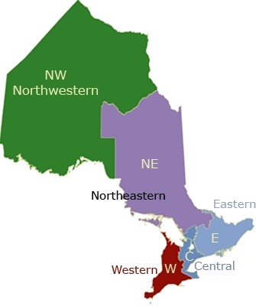

**1.6%**

**15.4%**

**3.7%**

**18.5%**

**60.8%**

**Board of Negotiation**

**About the BON**

The **Board of Negotiation (BON)** conducts mediation in the event of a dispute over the value of land expropriated by a public authority. If no settlement is reached, the matter may be appealed to the Ontario Municipal Board (OMB).

**How Cases Are Resolved**

The BON provides mediation services to parties involved in disputes over the value of expropriated land. BON mediations involve the landowner and the expropriating authority (typically the Crown or a municipality). There is no cost to the party to use the BON mediation process.

The BON views the expropriated property, reviews all written documentation and considers the submissions from the parties. Through mediation, the BON tries to help the parties reach a resolution. While it has no power to impose a settlement, the BON will, where sufficient information has been submitted, provide a recommendation to the parties on what would be fair compensation.

If a settlement cannot be reached at the BON, the parties may take the matter to the OMB. However, BON mediation is confidential, and the BON and the OMB employ strict measures to ensure that any information received by the BON is not provided to the OMB. OMB members and staff do not have access to any information or discussions that were part of the BON process.

**BON Caseload and Analysis**

The BON’s 2016-17 incoming caseload increased by 24 per cent over the previous year, and it is anticipated that with continued infrastructure spending in Ontario for highway and public transit expansions, the caseload will continue to grow. As in previous years, the greater percentage of cases continues to be in the central region.

**BON Case Results**

|  |  |  |  |
| --- | --- | --- | --- |
| **Fiscal Year** | **2014-2015** | **2015-2016** | **2016-2017** |
| Tribunal Resolved | 29 | 33 | 31 |
| Parties Resolved | 18 | 21 | 24 |
| Filed with OMB | 7 | 8 | 10 |
| Administratively Closed  (due to inactivity) | 0 | 6 | 3 |
| **TOTAL** | **54** | **68** | **68** |

**\*Note:** Cases may include more than one appeal.

**Conservation Review Board**

**About the CRB**

The **Conservation Review Board** **(CRB)** conducts proceedings where there are disputes concerning properties that may demonstrate cultural heritage value or interest, or disputes surrounding archaeological licensing. For those cases requiring a formal public hearing, the CRB issues a recommendation report to the final government decision maker.

**How Cases Are Resolved**

All cases before the CRB go through a pre-hearing process. This may include, where appropriate, a confidential pre-hearing settlement conference. The pre-hearing process provides an opportunity for all parties to discuss the issues with each other and with the CRB. The two fundamental objectives in conducting pre-hearings are to facilitate a possible settlement of the dispute and to prepare all parties for the formal hearing process if a settlement does not occur.

If a full settlement is reached at the pre-hearing or through a settlement conference, each objector and the property owner (if applicable) must submit a letter of withdrawal of objection to the CRB, or the municipality must submit a letter of withdrawal of the notice of intention to designate, and the case is closed. If a settlement is not reached, the pre-hearing will be used to prepare all parties for the formal hearing.

After the hearing, the CRB issues a report to the municipal council or the Minister of Tourism, Culture and Sport (whichever has jurisdiction over the matter), making recommendations based on the evidence presented and arguments made at the hearing. The CRB attempts to release the report within 30 days of the end of the hearing, and once released, the file is closed. The municipal council or the Minister makes the final decision on the matter, and will consider the report of the CRB as part of the decision-making process.

**CRB Caseload and Analysis**

Over the 2016-17 fiscal year, the CRB saw another marked increase in files received. There were 21 files received, with 18 of them received under section 29 of the *Ontario Heritage Act*, “Designation by municipal by-law”.

The CRB continues to offer settlement discussions through its use of pre-hearing conferences and pre-hearing settlement conferences, which contributes to its number of withdrawals. In total, 16 files were resolved during the past fiscal year with 11 of those being resolved due to withdrawal. The CRB held 44 hearing events, which includes pre-hearing conferences, pre-hearing settlement conferences and hearings. Five hearings were held, and for each one, a report was made to the relevant municipal council. The CRB had 24 active files as of March 31, 2017.

**CRB File Types**

|  |  |  |  |  |  |  |
| --- | --- | --- | --- | --- | --- | --- |
| **Fiscal Year** | **2014-15** | | **2015-16** | | **2016-17** | |
| **File Types Received**  **(Objections and Applications)** | **No. of Cases\*** | **No. of Appeals** | **No. of Cases\*** | **No. of Appeals** | **No. of Cases\*** | **No. of Appeals** |
| Intention to designate property by municipality | 7 | 10 | 10 | 10 | 18 | 18 |
| Designation by-law amendment | 0 | 0 | 1 | 1 | 2 | 2 |
| Designation by-law- request for repeal by owner | 0 | 0 | 1 | 1 | 0 | 0 |
| Designation by-law -objection to repeal | 1 | 2 | 3 | 4 | 1 | 1 |
| Archaeological licensing | 0 | 0 | 1 | 1 | 0 | 0 |
| **TOTAL** | **8** | **12** | **16** | **17** | **21** | **21** |

**\* Note:** One case represents all the individual appeals that are received regarding a specific Notice of Intention to Designate.

**CRB Case Results**

|  |  |  |  |
| --- | --- | --- | --- |
| **Fiscal Year** | **2014-2015** | **2015-2016** | **2016-2017** |
| Reports Issued | 2 | 3 | 5 |
| Withdrawals* | 9 | 5 | 11 |

**\*Note:** Withdrawals are often the result of a settlement of the issues among the parties.

**CRB Geographical Breakdown of Intake**

**2016-2017**



**7%**

**73%**

**20%**

**Environmental Review Tribunal**

**About the ERT**

The **Environmental Review Tribunal** **(ERT)** hears applications and appeals under numerous environmental and planning statutes. The ERT also functions as the Niagara Escarpment Hearing Office to hear development permit appeals and Niagara Escarpment Plan amendment applications for the protected World Biosphere Reserve. It also serves as the Office of Consolidated Hearings to hear applications for joint hearings, where separate hearings before more than one tribunal would otherwise be required.

**How Cases Are Resolved**

The ERT holds pre-hearing conferences on most matters. Pre-hearing conferences provide an opportunity to clarify, refine or settle the issues, as well as establish procedural directions in preparation for the main hearing. Pre-hearing conferences also provide an opportunity for members of the public to request status to participate in the main hearing. The presiding member typically issues a written order after a pre-hearing conference, noting what was decided and any directions given by the member.

ERT members are responsible for conducting pre-hearings and hearings, and for issuing written decisions, orders, reports and recommendations. ERT’s case management staff members process the appeals and applications, including the administrative duties to schedule and resolve an appeal/application, from the date of filing to the closing of the file.

The ERT also offers mediation to parties who wish to attempt to settle all or some of the issues raised in a dispute. Mediation can eliminate the need for a hearing or reduce the number of hearing days required.

**Changes to Legislation and Rules**

Three new statutes were passed in the spring of 2016 – the *Climate Change Mitigation and Low-carbon Economy Act, 2016*, the *Waste Diversion Transition Act, 2016* and the *Resource Recovery and Circular Economy Act, 2016* – which gave jurisdiction to the ERT to conduct hearings of appeals made pursuant to these acts. Under the *Climate Change Act*, the Ministry of Environment and Climate Change (MOECC) has the authority to make decisions and issue orders to ensure the integrity and effective operation of Ontario’s Cap and Trade program. Under the *Waste Diversion Transition Act* and the *Resource Recovery* *Act*, the Resource Recovery and Productivity Authority ( “Authority”) is responsible for issuing compliance orders and fines to ensure regulations are followed. These regulations are designed to transition Ontario to a waste-free society. Persons subject to a decision or order from the MOECC or the Authority may appeal to the ERT.

The ERT also made revisions and housekeeping amendments to its Rules of Practice and Practice Directions. The September 12, 2016 changes incorporate the ERT’s three new statutes, clarify the requirements for providing a notice of allegation, update the procedures for making cost applications based on changes to the *Statutory Powers Procedure Act*, change the end of business day time, and update terms and definitions. The changes and updates reflect the requirements of the ERT’s governing legislation and provide more consistency and clarity to the ERT’s processes.

**ERT Caseload and Analysis**

The ERT continues to close approximately the same number of cases it receives each year.

There was a decrease in the total number of cases the ERT received in the 2016-17 fiscal year, which is largely attributed to a temporary decrease in the number of appeals of renewal energy approval decisions that were made by the MOECC. The ERT expects this number to increase to its regular level in the upcoming 2017-18 fiscal year as decisions on a new batch of renewable energy approval applications are made by the MOECC.

Despite the decrease in renewable energy approval appeals, the ERT’s hearing volume remained relatively the same due to a few complex cases involving a large number of hearing events. The ERT continues to make good use of mediation to eliminate the need for a hearing.

**ERT Cases Received by Type**

|  |  |  |  |  |  |  |
| --- | --- | --- | --- | --- | --- | --- |
| **Case Type** | **2014-15** | | **2015-16** | | **2016-17** | |
| **No. of Cases** | **No. of Appeals** | **No. of Cases** | **No. of Appeals** | **No. of Cases** | **No. of Appeals** |
| *Environmental Bill of Rights, 1993* | 3 | 13 | 5 | 8 | 6 | 20 |
| *Environmental Protection Act* | 18 | 28 | 25 | 102 | 18 | 27 |
| *Environmental Protection Act* – Renewable Energy Approval Appeals | 11 | 18 | 9 | 19 | 1 | 1 |
| *Nutrient Management Act, 2002* | 0 | 0 | 1 | 1 | 0 | 0 |
| *Ontario Water Resources Act* | 5 | 9 | 0 | 0 | 2 | 4 |
| *Pesticides Act* | 1 | 4 | 0 | 0 | 0 | 0 |
| *Safe Drinking Water Act, 2002* | 0 | 0 | 3 | 3 | 0 | 0 |
| *Niagara Escarpment Planning and Development Act* | 12 | 32 | 24 | 81 | 19 | 36 |
| *Consolidated Hearings Act* | 0 | 0 | 1 | 1 | 0 | 0 |
| **TOTAL** | **50** | **104** | **68** | **215** | **46** | **88** |

**\*Note:** Cases may include more than one appeal.

**2016-2017**

**ERT Geographical Breakdown of Intake**



**13%**

**7%**

**24%**

**56%**

**Ontario Municipal Board**

**About the OMB**

The **Ontario Municipal Board** **(OMB)** hears applications and appeals in relation to a range of municipal planning, financial and land matters, including: official plans, zoning by-laws, subdivision plans, consents, minor variances, land compensation, development charges, electoral ward boundaries, municipal finance, aggregate resources and other issues assigned to the OMB by numerous Ontario statutes.

**How Cases Are Resolved**

Most disputes are brought to the OMB by filing an appeal. Depending on the type of dispute, there are different processes and timelines for filing an appeal. The OMB reviews the appeal and decides, with input from the parties, to stream the case into mediation, motion, pre-hearing or hearing.

The OMB uses the pre-hearing process for members to manage complex or multi-party appeals of related municipal land use matters. Through this process, members use techniques that include: identifying, prioritizing and refining issues, providing detailed procedural instructions or hearing work plans to the parties, and providing direction on any procedural disputes. As a result, hearing events have become more focused and efficient in dealing with issues that are critical to the resolution of the appeals.

The OMB holds hearings across the province, most often in the municipality where the property is located. The OMB also holds hearing events by teleconference when it is appropriate, often for events such as pre-hearings and settlement hearings. The use of teleconferences allows the OMB to respond quickly and is both time and cost-efficient for the parties.

**Changes to Legislation and Rules**

The OMB made a housekeeping change to its Rule of Practice and Procedure to assist in the delivery of tribunal decisions by email. Tribunal decisions or orders now take effect on the date of electronic delivery, unless stated otherwise in the decision or order. Over the past year, considerable attention was directed to internal administrative efficiencies to implement amendments to the *Planning Act* which arose from *the Smart Growth for Our Communities Act, 2015*. Initial stakeholder consultation regarding the implications of this legislation was undertaken, and potential rule changes are now under consideration.

**OMB Caseload and Analysis**

Minor variance matters account for the highest percentage of new files received, representing 43 per cent of intake during this fiscal year. They are followed by zoning refusals, consents, zoning by-laws enacted by the municipality, and official plans and amendments.

Geographically, files involving the City of Toronto continue to account for the highest percentage of intake at 44 per cent for the year. With the addition of the other areas, the total intake from the central region accounts for 78 per cent of intake for the year.

The OMB continues to manage and adjudicate complex matters in a number of areas, including: appeals of municipal approvals related to financial matters, land compensation matters, official plan appeals of Growth Plan conformity amendments and site specific land use appeals that have an impact on communities. The pre-hearing process is critical to the management of such cases. A successful pre-hearing process allows hearing events to be refined, focused and efficient. Pre-hearing events represent 31 per cent of the hearing events held this year.

In the 2016-17 fiscal year, the OMB scheduled 1,978 hearing events – a slight decrease from 2,012 hearings events held the previous fiscal year – while the number of hearing events actually held remained relatively constant. The majority of hearing events, 88 per cent, were scheduled for one day or less. The number of hearings requiring 10 days or longer remained the same as last fiscal year, at a rate of under one per cent.

The OMB’s mediation program continues to provide timely and cost effective resolutions to disputes related to site specific land use and complex land compensation matters. This program has avoided the need for a number of long hearings.

**OMB Files Received by Type**

|  |  |  |  |  |  |  |
| --- | --- | --- | --- | --- | --- | --- |
| **Fiscal Year** | **2014-2015** | | **2015-2016** | | **2016-2017** | |
| **File Types Received**  **(Appeals and Applications)** | **No. of Files** | **No. of Appeals** | **No. of Files** | **No. of Appeals** | **No. of Files** | **No. of Appeals** |
| Minor Variances | 573 | 602 | 613 | 651 | 632 | 650 |
| Consents | 232 | 237 | 180 | 189 | 159 | 163 |
| Zoning By-laws | 181 | 293 | 143 | 229 | 140 | 655 |
| Official Plans and  Official Plan Amendments | 177 | 692 | 141 | 231 | 139 | 514 |
| Zoning Refusal or Inaction | 166 | 166 | 160 | 160 | 166 | 166 |
| Plans of Subdivision/  Condominium | 77 | 85 | 57 | 57 | 55 | 58 |
| Municipal and Miscellaneous  (incl. site plans) | 129 | 139 | 104 | 150 | 111 | 146 |
| Development Charges | 30 | 83 | 18 | 28 | 19 | 22 |
| Land Compensation | 36 | 36 | 36 | 36 | 42 | 42 |
| Municipal Finance | 3 | 3 | 8 | 8 | 4 | 4 |
| **TOTAL** | **1,604** | **2,336** | **1,460** | **1,739** | **1,467** | **2,420** |

**\*Note:** Cases may include more than one appeal.



**2016-2017**

**OMB Geographical Breakdown of Intake**

**1%**

**8%**

**1%**

**78%**

**12%**

**The Future of ELTO**

Environment and Land Tribunals Ontario (ELTO) is committed to improving its operations while maintaining the highest standards of administrative justice. The future of ELTO lies in continuing its efforts in the three strategic directions identified in its business plan.

The first of these is “public dispute resolution services.” This supports ELTO’s core business of resolving disputes by providing the public with services that are accessible and lead to timely and appropriate resolution. ELTO recognizes that not all disputes require a full hearing and that parties should have access to alternative methods to help resolve their matter. ELTO is committed to ensuring that the public receives a fair timeline and a high-quality resolution to their dispute, by providing them with information on when they should use tribunals and what they should expect during the process.

The second strategic direction involves “modernization and transformation.” ELTO is committed to serving the needs of Ontarians by improving rules, processes and technology to ensure inclusiveness and accessibility of its services. ELTO is proactively preparing for this by working with stakeholders, reviewing its constituent tribunals’ rules and developing improved processes to streamline services. ELTO is also working with other adjudicative clusters to identify opportunities for service integration and the sharing of best practices to increase its effectiveness. ELTO is working towards providing improved access and green solutions for all Ontarians through a variety of formats, including:

* Alternative hearing formats that reduce the requirement for travel.
* Electronic data capture and access to information that reduces the reliance on paper.
* Process improvements that increase efficiency in operations.

The third strategic direction is “building an engaged and vibrant workplace.” ELTO is committed to having timely and responsive succession plans and recruitment processes, for both adjudicators and staff, to ensure that ELTO has the skilled resources it requires.

ELTO aims for everyone in the organization to be engaged and support continuous improvement and transformation. It continues to develop and nurture a responsive workplace to ensure future adaptability. By recruiting talent with the appropriate skills and knowledge, ELTO will have the capacity to advance its strategic initiatives.

**Strategic Direction 1: Public Dispute Resolution Services**

* Enhance public facing website by reorganizing content, improving accessibility, ease of use and the overall client experience by spring 2017.
* Update and improve accessibility of all Environmental Review Tribunal (ERT) Appeal and Application Guides by summer 2017.
* Provide further training and information sessions to City of Toronto staff for the Local Appeal Board, by spring 2017 or as requested.
* Create forms that are easy to complete, enhanced with accessibility features and pilot Ontario Municipal Board (OMB) appeal forms by spring 2017.
* Enhance performance measures and service standards, including development of a public services survey, by fall 2017.
* Develop enhanced case management tracking systems.
* Develop guidelines for the filing of electronic documents when ordered as part of the hearing process.

**Strategic Direction 2: Modernization and Transformation**

* Modernize electronic data sharing between Assessment Review Board (ARB) statutory parties, including new real time property sharing from the Municipal Property Assessment Corporation (MPAC) to the ARB case management system on active appeals, with a target date of end of fiscal.
* OMB Mandate Review is expected to result in new legislation, and will likely be introduced in spring 2017. While ELTO’s processes will be revised accordingly, implementation will be dependent on the legislation and recommendations.

**Strategic Direction 3: Engaged and Dynamic workplace**

* Continue to implement adjudicator succession and recruitment plans. This will be an ongoing initiative.
* Implement an adjudicator performance evaluation system by winter 2017-18.
* Develop an annual integrated professional development strategy/plan by spring 2017.
* Developing a cross-tribunal administrative training program to better utilize resources and enhance engagement and learning for staff by fall 2017.
* Develop on-line professional development courses by fall 2017.

Through the implementation of these and other key deliverables and initiatives, ELTO seeks to continually improve its services for the public.

**Appendix A: ELTO’s Appointees**

| Name | Tribunal | Position | Original Appointment Date | Appointment End Date |
| --- | --- | --- | --- | --- |
| Andrews, Peter | ARB | Full-Time Vice-Chair | 14-Nov-12 | 13-Nov-17 |
| Awoleri, Subuola | ARB | Part-Time Member | 22-Oct-14 | 21-Oct-16* |
| Full-Time Member | 16-Nov-16 | 15-Nov-18 |
| Bellemere, Michel | OMB | Full-time Member | 08-Aug-16 | 07-Aug-18 |
| Bourassa, Marcelle | ARB | Full-Time Vice-Chair | 11-Apr-06 | 20-Feb-17* |
| Full-Time Member | 21-Feb-17 | 20-Feb-19 |
| BON | Part-Time Member | 06-May-15 | 05-May-20 |
| Bruce, Laurie | ERT, OMB | Part-Time Member | 22-Oct-14 | 21-Oct-17 |
| Carter-Whitney, Maureen | ERT | Part-Time Member | 04-May-11 | 11-Oct-16* |
| OMB | Full-Time Member | 15-Aug-12 | 14-Aug-17 |
| ERT | Full-time Vice-Chair | 11-Oct-16 | 10-Oct-18 |
| Cashin, Marlene | ERT | Part-Time Member | 22-Oct-14 | 21-Oct-19 |
| Chee-Hing, Jason | OMB | Full-Time Member | 01-Sep-04 | 31-Aug-17 |
| Conti, Chris | OMB | Full-Time Member | 03-Jul-07 | 02-Jul-17 |
| Cowan, Bernard A. | ARB | Full-Time Member | 19-Dec-97 | 03-Sep-17 |
| DeMarco, Jerry V. | ELTO | Full-Time Alternate Executive Chair | 01-Sep-10 | 31-Aug-20 |
| CRB | Part-Time  Associate Chair | 08-May-13 | 31-Aug-20 |
| ERT | Full-Time  Associate Chair | 01-Sep-10 | 31-Aug-20 |
| Denhez, Marc | CRB | Part-Time Member | 18-Apr-12 | 17-Apr-17 |
| OMB | Full-Time Member | 31-May-04 | 30-Oct-16* |
| Denison, William T. | ARB | Part-Time Member | 14-Nov-12 | 13-Nov-17 |
| Driesel, Sandra | ARB | Part-Time Member | 16-Mar-00 | 23-Apr-16* |
| Duncan, Justin | ERT, OMB | Full-Time Member | 23-Jul-14 | 22-Jul-19 |
| Egan, Terry | BON | Part-Time Member | 17-Jun-09 | 16-Jun-19 |
| Fenus, Andrew | ARB | Part-Time Member | 30-May-07 | 29-May-17 |
| Flemming, Leslie | ARB | Part-Time Member | 02-Oct-13 | 01-Oct-18 |
| Gibbs, Heather | ERT | Full-Time Vice-Chair | 20-Sep-06 | 21-Feb-18 |
| OMB | Part-Time Member | 23-Mar-16 | 23-Sep-17 |
| Griffith, Jennifer | ARB | Part-Time Member | 17-Sep-04 | 16-Sep-16* |
| Hefferon, Colin | OMB | Full-Time Member | 20-Sep-06 | 19-Sep-16* |
| Henderson, Stuart | CRB | Part-Time Member | 28-Jun-06 | 27-Jun-16* |
| Hodgins, Thomas | OMB | Full-Time Member | 11-Oct-16 | 10-Oct-18 |
| Hussey, Karlene | OMB | Full-Time Vice-Chair | 20-Apr-05 | 03-Jan-21 |
| Jackson, Helen | ERT, OMB | Full-Time Member | 24-May-11 | 23-May-21 |
| Jacobs, Sarah | ERT | Full-Time Member | 23-Jul-14 | 22-Jul-16* |
| OMB | Full-Time Member | 23-Jul-14 | 22-Jul-19 |
| Jones, Richard Coleman | OMB | Part-Time Member | 22-Oct-14 | 21-Oct-17 |
| Kowarsky, Barbara | ARB | Part-Time Member | 18-May-05 | 17-May-16* |
| Kraft-Sloan, Karen | ERT, OMB | Full-Time Member | 23-Jul-14 | 22-Jul-16* |
| ERT | Part-Time Member | 23-Jul-16 | 22-Jul-19 |
| Krushelnicki, Bruce | ELTO | Full-Time  Executive Chair | 25-Nov-15 | 24-Nov-18 |
| Krzeczunowicz, Stefan | OMB | Full-Time Member | 08-Aug-16 | 07-Aug-18 |
| Laflamme, Jacques | ARB | Part-Time Member | 25-Aug-04 | 24-Aug-16* |
| Lanthier, David | OMB | Full-Time Member | 04-May-16 | 03-May-18 |
| LaRegina, Anthony | ARB | Part-Time Member | 15-Jan-07 | 14-Jan-17* |
| Full-Time Member | 31-Jan-17 | 01-Feb-19 |
| Lee, Wilson S. | OMB | Full-Time  Associate Chair | 01-Jul-88 | 31-Oct-16*  (resigned) |
| Part-Time Member | 19-Jan-17 | 18-Jan-18 |
| Levy, Alan | ERT | Part-Time Member | 09-May-07 | 08-May-17 |
| Light, Sonia | ARB | Part-Time Member | 07-Aug-13 | 06-Aug-18 |
| Limoges, Rick | ARB | Part-Time Member | 15-Jan-07 | 14-Jan-17* |
| Makuch, Richard G.M. | ARB | Part-Time Member | 06-Nov-13 | 05-Nov-18 |
| OMB | Full-Time Member | 13-Jun-12 | 12-Jun-17 |
| Marques, Ana Cristina | ARB | Part-Time Member | 18-May-05 | 17-May-16* |
| BON | Part-Time Member | 06-Nov-13 | 05-Nov-18 |
| McAnsh, Scott | ARB | Full-Time Member | 24-Feb-16 | 23-Feb-18 |
| McKenzie, James | OMB | Full-Time Vice-Chair | 03-Jul-07 | 02-Feb-17* |
| OMB | Full-Time Associate Chair | 02-Feb-17 | 01-Feb-19 |
| McLeod-Kilmurray, Heather | ERT | Part-Time Member | 04-May-11 | 03-May-17 |
| Milbourn, Paul | ERT | Part-Time Member | 05-Dec-12 | 04-Dec-17 |
| Milchberg, Anne | OMB | Part-Time Member | 22-Oct-14 | 21-Oct-17 |
| Morris, Warren | ARB | Part-Time Member | 31-Oct-12 | 30-Oct-17 |
| Muldoon, Paul | ARB | Full-Time  Associate Chair | 01-Jun-14 | 31-May-19 |
| ERT | Full-Time Vice-Chair | 04-Apr-06 | 03-Apr-16* |
| Murdoch, Su | CRB | Part-Time Vice-Chair | 16-Feb-05 | 08-May-17 |
| Nelson, Daniel | CRB | Part-Time Member | 22-Oct-14 | 21-Oct-19 |
| Neron, Robert | ARB, BON | Part-Time Member | 28-Aug-13 | 27-Aug-18 |
| Okhovati, Margarita | ARB | Part-Time Member | 22-Oct-14 | 21-Oct-19 |
| Philcox, Frank | ERT | Part-Time Member | 22-Oct-14 | 21-Oct-16* |
| Plumstead, Nicoll | ARB | Part-Time Member | 18-May-05 | 17-May-16* |
| Roberts, Catherine E. | ARB | Part-Time Member | 29-Sep-10 | 21-Dec-16*  (resigned) |
| Rossi, Reid | OMB | Full-Time Member | 31-May-04 | 30-May-16* |
| Rowe, Ian | OMB | Part-Time Member | 11-Oct-16 | 10-Oct-18 |
| Saponara, Fausto | ARB | Part-Time Member | 18-May-05 | 17-May-16* |
| Schiller, Susan | ARB | Part-Time Vice-Chair | 06-Nov-13 | 05-Nov-18 |
| ERT | Part-Time Vice-Chair | 06-Nov-13 | 05-Nov-18 |
| OMB | Full-Time Vice-Chair | 06-Sep-05 | 03-Jan-21 |
| Seaborn, Jan de Pencier | OMB | Full-Time Vice-Chair | 31-May-00 | 22-Mar-18 |
| Sharma, Marilyn | ARB | Part-Time Member | 15-Jan-07 | 14-Jan-17* |
| Sills, Mary-Anne | OMB | Full-Time Member | 03-Jul-07 | 02-Jul-17 |
| Skanes, Tyrone | ARB | Part-Time Member | 29-Sep-10 | 28-Sep-20 |
| Smith, Laurie | CRB | Part-Time Member | 08-Sep-14 | 07-Sep-19 |
| Sniezek, Joseph | OMB | Part-time Member | 23-Jun-04 | 22-Jun-16* |
| Spraggett, Mark | ARB | Part-Time Member | 22-Oct-14 | 21-Oct-19 |
| Stabile, Vincent | ARB | Part-Time Member | 29-Sep-10 | 28-Sep-20 |
| Stefanko, Steven | OMB | Full-Time Vice-Chair | 20-Apr-05 | 29-Nov-16*  (resigned) |
|  |  |  |  |  |
| Steinberg, Robert | ARB | Part-Time Member | 14-Nov-12 | 13-Nov-17 |
| BON | Part-Time Member | 04-May-11 | 03-May-21 |
| Sutherland, Sylvia | OMB | Full-Time Member | 21-Mar-07 | 20-Mar-17* |
| Swinkin, Gerald | OMB | Full-Time Member | 24-Aug-16 | 23-Aug-18 |
| Taylor, Blair S. | OMB | Full-Time Member | 17-Oct-12 | 16-Oct-17 |
| Taylor, Ian | BON | Part-Time Member | 20-Jun-07 | 19-Jun-17 |
| Valiante, Marcia | ERT | Full-Time Member | 09-May-07 | 22-Jul-16* |
| OMB | Full-Time Member | 23-Jul-14 | 22-Jul-16* |
| ERT, OMB | Part-Time Member | 23-Jul-16 | 22-Jul-19 |
| VanderBent, Dirk | ARB | Part-Time Vice-Chair | 06-Nov-13 | 18-Sep-16 |
| ERT | Full-Time Vice-Chair | 18-Sep-06 | 17-Sep-16* |
| ARB | Full-Time Vice-Chair | 18-Sep-16 | 17-Sep-18 |
| Vincent, Sharyn | OMB | Full-Time Member | 27-Jun-16 | 26-Jun-18 |
| Walker, Janet Lea | ARB | Full-Time Member | 04-Sep-07 | 03-Sep-17 |
| Weagant, Dan | ARB | Part-Time Member | 29-Sep-10 | 29 Sep-16* |
| ARB | Full-Time Member | 29-Sep-16 | 28-Sep-19 |
| Whitehurst, Donald | ARB | Full-Time Member | 18-May-05 | 03-Sep-17 |
| Wilkins, Hugh | ERT | Full-Time Member | 02-Apr-14 | 01-Apr-19 |
| OMB | Part-Time Member | 02-Mar-16 | 01-Aug-17 |
| Wright, Robert | CRB | Part-Time Vice-Chair | 29-May-13 | 28-May-18 |
| ERT | Full-Time Vice-Chair | 27-Aug-07 | 26-Aug-17 |
| OMB | Part-Time Member | 06-Apr-16 | 05-Oct-17 |
| Wyger, Joseph M. | ARB | Full-Time Member | 27-May-98 | 03-Sep-17 |
| Yuen, Jane | BON | Part-Time Member | 19-Dec-08 | 18-Dec-18 |
| Zuidema, Jyoti | OMB | Full-Time Vice-Chair | 20-Aug-07 | 19-Aug-17 |

*Indicates appointees who were no longer with ELTO as of March 31, 2017 or whose position at ELTO changed in the 2016-17 fiscal year.

1. Deeming: When ARB has not resolved an assessment appeal by March 31st of the year following the year under appeal, a new appeal will be administratively created for the next tax year. For example, if a decision on a 2017 appeal is not issued by March 31, 2018, a new appeal would be created for the 2018 tax year without requiring the appellant to resubmit their appeal and pay any additional appeal fees. The 2018 appeal would be considered the “deemed” appeal.